Project Design Phase-II
Technology Stack (Architecture & Stack)

Date | 08 July 2026
Team ID
Project Name | Sports Hall Booking System
Maximum Marks | 4 Marks
Technical Architecture:

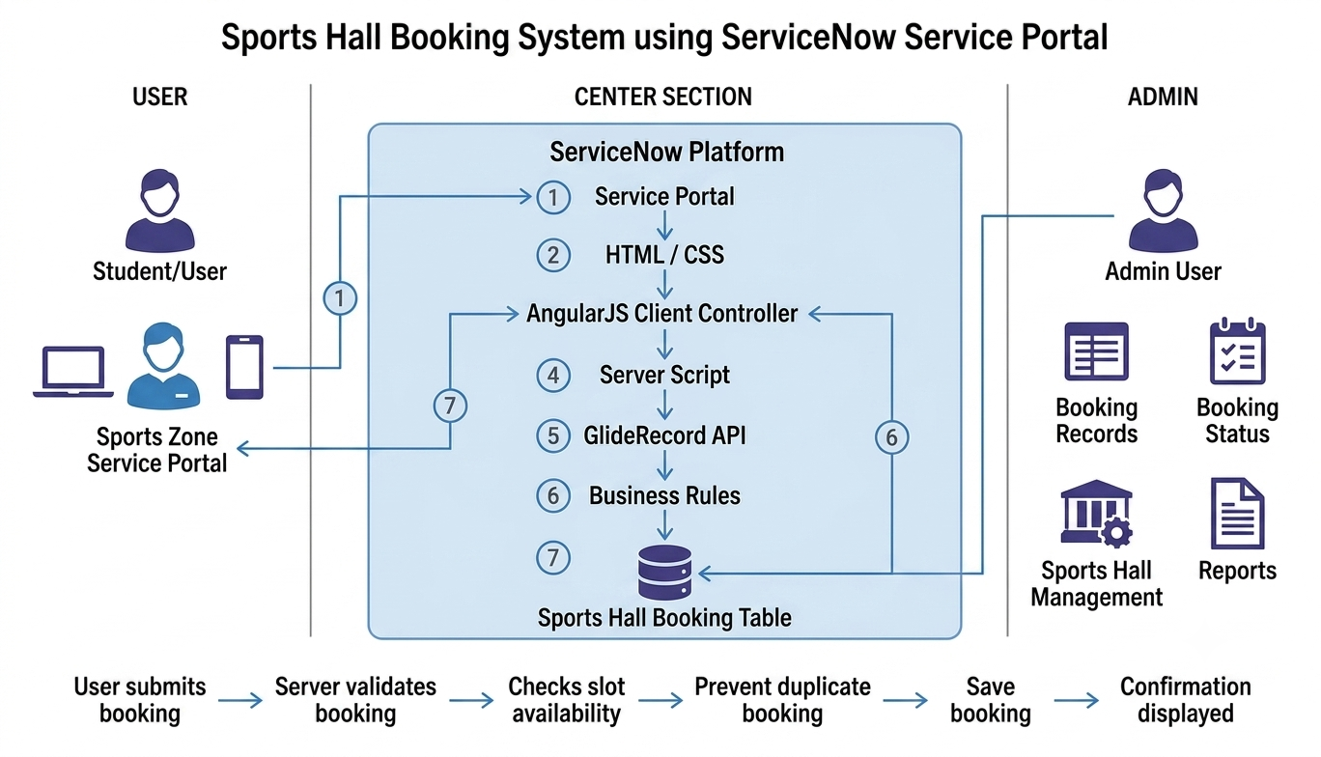

Technology Stack :

Category | Technology / Tool | Purpose
User Interface | ServiceNow Service Portal | Provides a user-friendly web interface for students to book sports halls and manage reservations.
Frontend Development | HTML5 | Used to create the structure and layout of booking pages and portal widgets.
Frontend Styling | CSS3 | Used for designing responsive layouts, blue-themed UI components, buttons, and booking cards.
Client-Side Logic | AngularJS Client Controller | Handles user interactions, form validation, slot selection, and dynamic updates in the portal.
Server-Side Logic | ServiceNow Server Script | Processes booking requests, validates availability, calculates charges, and communicates with the database.
Database Management | ServiceNow Tables | Stores sports hall details, user bookings, time slots, booking status, and payment information.

Business Rules | ServiceNow Business Rules | Implements backend validation such as preventing duplicate bookings and maintaining data consistency.
User Management | ServiceNow User Management | Provides authentication and controls access to booking services.
Development Environment | ServiceNow Studio / Service Portal Designer | Used for creating applications, widgets, tables, and configurations.
Testing & Debugging | ServiceNow System Logs | Used to monitor scripts, debug errors, and verify application behavior.

